Starting School
We aim to ensure that this new experience in your child’s life is enjoyable. To help your child prepare by getting to know his/her teacher, classmates and the layout of the classroom, we organize pre-school visits in the preceding term. There is also a new parents’ Information Evening, where parents can talk to the Reception teachers and find out about some of the activities, which their children will enjoy.

We are grateful for the help of the leaders of St John’s Preschool who help to prepare the children for ‘Big School’.

Parental Involvement
Parents' Evenings are held once a term when parents are invited to discuss their child or children's progress with their teachers. Written reports are sent to all parents in the summer term but parents should consult their child's teacher if they have any concerns. Teachers consult parents at an early stage if they have any worries.

. Parents are welcome to come into school to help the children either in their own child's class or in another age group. The parents who come in regularly are a tremendous help and we hope they also enjoy themselves. There are many ways that parents use their time and talents to help us and ultimately it is the children who benefit.
“A distinctive feature of the school is the large number of adults involved in teaching and support in classes. As well as teachers, teaching assistants, both general and those supporting pupils with learning difficulties, parents helping in school, student teachers and students on work experience all make a significant contribution to learning.”
Ofsted

Reading

At St John's we use the Ready Steady Phonics scheme for phonics: https://www.readysteadyphonics.co.uk/
The scheme is used until children are fluent and we have a consistent approach to reading following training for all staff.
Children will receive a reading book based on their phonics learning which will be fully decodable. We encourage you to continue to read to your child as well and will provide support with this during your time at St John's.
. This ensures a breadth of experience taking into account the children's various needs as they develop their reading skills. We have a strongly phonic based approach to initial reading skills.
The home-school reading system relies on the reading record books, which are used to record progress in reading and provide a daily dialogue between parent and teacher.
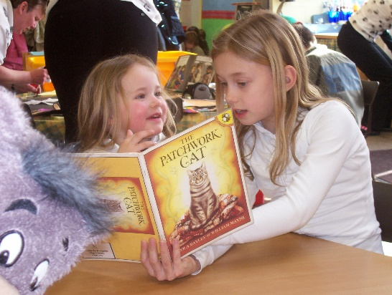
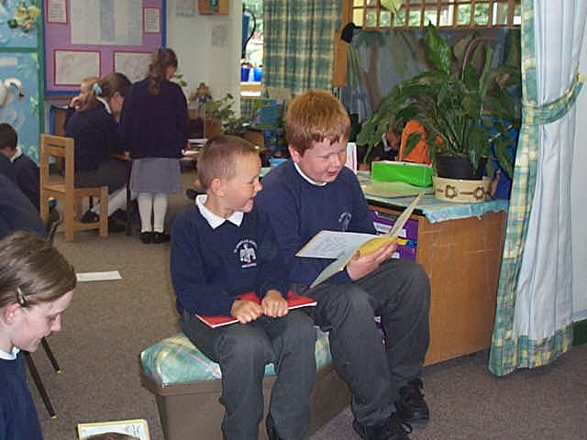

Pastoral Care and Behaviour

At St John the Evangelist Primary School, we aim to develop caring attitudes in the children. The relationships, which they develop with their teachers and others in the school community, set the standards of behaviour for themselves and others. It is essential that the children take a pride in their school, their work and themselves. We control movements throughout the school, supervise children both at work and play and encourage a strong sense of self discipline.

Our school is a happy and friendly place where children learn in a secure and caring community. Children are encouraged to develop respect and responsibility within a well ordered environment, where all staff have high expectations of appropriate behaviour. We teach children to acknowledge the effects of their behaviour on others. Generally our children meet these expectations and on these occasions their positive behaviour is promoted through a ‘rewards’ system. Negative behaviour is dealt with through a series of ‘consequences’ of which all of the children are aware. In the event of a child’s behaviour causing particular concern, we would be involved in working together with parents to establish an improvement in this area.

Our approach to personal and social education is built upon the desire to enable children to be aware of their social and moral obligations to themselves and others, both at school and in the outside world.

A Home-School Agreement emphasises our commitment to good behaviour and has involved pupils, parents, governors and staff.

Illness and Accidents
If your child is ever absent through illness, then please contact the school on the first day of absence.
There can be times when we need to contact you quite quickly. Children who become ill during the day might need to go home. There is also the chance (not too often we hope) that there could be some sort of accident. This is what we will do: -
- We will try to contact you by telephone.
- If there is no answer, then we will use the emergency contact number that you have given us on the admission form.
- If there is a serious accident (e.g. a break or deep wound) then we will act as quickly as possible. If it is necessary to send for an ambulance, then we will do this whilst trying to reach you. Please remember that the hospital will need your consent to treat your child. The telephone numbers kept in school are our link with you. Please keep us up to date if there are any changes.

Medicine in school
- The Headteacher and Bursar, have agreed with the Governing Body that they will undertake, in exceptional circumstances, to administer medication should this need to be given during the course of the school day (i.e. 8.55 a.m. – 3.20 p.m.)

Prescribed medicines
- The School will only accept medicines that have been prescribed by a doctor, dentist or nurse practitioner. Medicines should always be provided in the original container as dispensed by a pharmacist and includes the prescriber’s instructions for administration. We will not accept medicines that have been taken out of the container as originally dispensed nor make changes to dosage on parent’s instructions.

- In the event that medicine needs to be given during the school day – The School must receive a written request from the parent giving clear instructions regarding the required dosage. The necessary form should be completed by the parent whenever a request is made for medicine to be administered on each and every occasion.

Special Educational Needs

We believe that within our inclusive environment, all children have educational, social and emotional needs that are special to them. Some of the children will have specific needs, which require extra support and provision. These may be related to a delay in developing literacy and numeracy skills or because the child is very able and needs specific teaching to cater for his or her intellectual capabilities.

Our intention is to identify these needs as early as possible. Once identified, the child with difficulties or exceptional abilities will receive additional support from the class teacher and this will be monitored by the school’s Special Needs or Gifted and Talented Co-ordinator. If further support is required, the child will receive extra teaching, individually or in a group, from teaching assistants or our support teacher.

The school’s Special Educational Needs Co-ordinator liaises with other professionals within the LA and may refer children to other professionals, if necessary. We have a governor who is aware of the procedures relating to special needs within school.

Parents are consulted, informed and involved during all stages of the process.

The objectives of our Special Educational Needs Policy are as follows:

- To identify children with special educational needs.
- To provide ‘Individual Education Programmes’ for children with special educational needs.
- To evaluate each ‘Individual Educational Programme’ in relation to targets set and standards achieved.
- To evaluate the progress of children with special educational needs against National Curriculum criteria.
- To ensure that children with special educational needs have access to and are involved in all aspects of school life.

Timetable
School opens | 8.45 am  8.45 am | Key Stage 1 & Reception  Key Stage 2
Registration | 9.00 am  9.00 am | Key Stage 1 & Reception  Key Stage 2
Assembly | Various timings | All children
Morning break | 10.30 am to 10.45 am | Infants (Key Stage 1) and  Juniors (Key Stage 2)
Lunch | 3 sittings  11.45am – 1.30pm | KS 1 & KS 2
KS1 & Reception home time | 3.15 pm
KS2 home time | 3.15 pm

And finally

Every Child is different

They look different

Behave differently

Develop at different times and at different rates

Learn at different times and in different ways

We are delighted to have your family with us – we hope you will all be happy in our school

