**A St John’s Writer**

***‘Children are a gift from the Lord’ (Psalm 127 v.3)***

**The vision of our school**

***St. John’s is a caring, Christian community striving to support its members to achieve their God given potential. Exploring our unique gifts and raising aspirations, we prepare our children for the challenges of the modern world. Following Jesus’ example, we seek to grow good people who can make a difference.***

**A Vision Statement for Writing**

We recognise that each and every children is a ‘…gift from the Lord’ consequently, developing and supporting every child in our care: spiritually, morally, socially, culturally and intellectually to become the best that they can be is fundamental to all that we do. We want our children to have the desire to aspire and achieve whatever they want in the world.

As with all curriculum subjects, our school’s Christian vision drives all of our learning in English lessons.

At St John’s, we ensure that all children see themselves as a writer. Writing is taught through The Write Stuff approach by Jane Considine. This method allows pupils to improve their oracy and widen their vocabulary in every lesson whilst deepening their understanding of writerly choices through the use of teacher modelling. All our writing is taught through the “writing rainbow” which provides a lens for the writer to focus through in order to ensure all writing is effective and engaging for the reader, whilst meeting the intended purpose.

**God in our Lives**

Our school is a safe place where curious children feel they can discuss and develop their understanding.

The texts used in our English lessons support our foundation subject learning and / or our PSHE. Pupils are given creative and engaging contexts to write within, encouraging them to become confident, fluent writers whilst also exploring their own place in the world and their values.

**Ignite your fire**

We ignite a passion and curiosity for writing by providing rich and engaging opportunities for the children to write, using texts that support other areas of our curriculum. All pupils believe themselves to be writers and experience writing success as they are supported through each stage of their writing from the initial ideas stage, with teacher modelling and peer support to their independent writing at the end of each unit of work.

**Family**

In writing lessons, the children work both independently and co-operatively. During the “initiate” stage, children work with their “chotting partner” to gather a bank of ideas for them to use when writing. Through this approach, pupils are encouraged to rely on each other: all children learn to depend on others, to listen and share ideas in a supportive way and celebrate others’ achievements.

**Truth**

Through the constant sharing of ideas and modelling of children’s writing, children are able to recognise that all of God’s children should be valued. Teachers can support and teach children how the different people’s ideas and contributions work together to produce that perfect piece of writing.

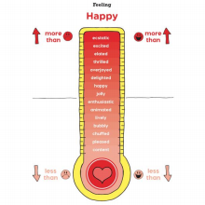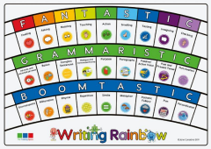

“When I am stuck, I can magpie an idea from someone else.” Y3/4 child.

“When we are chotting, I find the sharing ideas bit helpful because I get some really good ideas for my writing that way.” Y5/6 child.