St John the Evangelist Primary School

Accessibility Plan 2022-25

St John the Evangelist Primary School has been described as having a “welcoming happy environment in which pupils thrive and want to do their best.” We want all children to enjoy school, to be challenged to achieve their very best, and to consider their time at the school as their own “learning adventure”. We are committed to giving all of our children every opportunity to achieve the highest of standards. We do this by taking account of pupils’ varied life experiences and needs. We offer a broad and balanced curriculum and have high expectations for all children. The achievements, attitudes and well being of all our children, matter.

Purpose of Plan.
This plan shows how St John the Evangelist Primary School intends, over time, to increase the accessibility of our school for disabled pupils, staff, parents/carers and visitors.

Definition of disability.
A person has a disability if they have a physical or mental impairment that has a substantial and long-term adverse effect on their ability to carry out normal day-to-day activities.

Areas of planning responsibilities.
- Increasing access for disabled pupils to the school curriculum (this includes teaching and learning and the wider curriculum of the school such as participation in after-school clubs, leisure and cultural activities or school visits).

- Improving access to the physical environment of schools (this includes improvements to the physical environment of the school and physical aids to access education).

- Improving the delivery of written information to disabled pupils (this will include planning to make written information that is normally provided by the school to its pupils’ available to disabled pupils. The information should take account of pupils’ disabilities and pupils’ and parents’ preferred formats and be made available within a reasonable timeframe).

Contextual Information
St John the Evangelist Primary School was built in 1970. Accommodation consists of the main school building, a satellite block and a prefab building. All classrooms are located at ground floor level. A disabled toilet is available in the satellite block, which was added to the main school accommodation in 2004

The main entrance to the school has wheelchair access and whilst a number of exit points from classrooms have steps, it is possible to navigate around school in a wheelchair with assistance to open doors.

At present we have no wheelchair dependent pupils, parents or members of staff.

Current Range of known disabilities.
The school has children with a range of disabilities including moderate and specific learning disabilities. We have a number of children with impaired motor skills but do not have any children who are unable to navigate their way around school because of a physical disability.

Increasing access for disabled pupils to the school curriculum.
Improving teaching and learning lies at the heart of the school’s work. Through self-review and Continuous Professional Development (CPD), we aim to enhance staff knowledge, skills and understanding to promote excellent teaching and learning for all children. We aim to meet every child’s needs within mixed ability, inclusive classes.

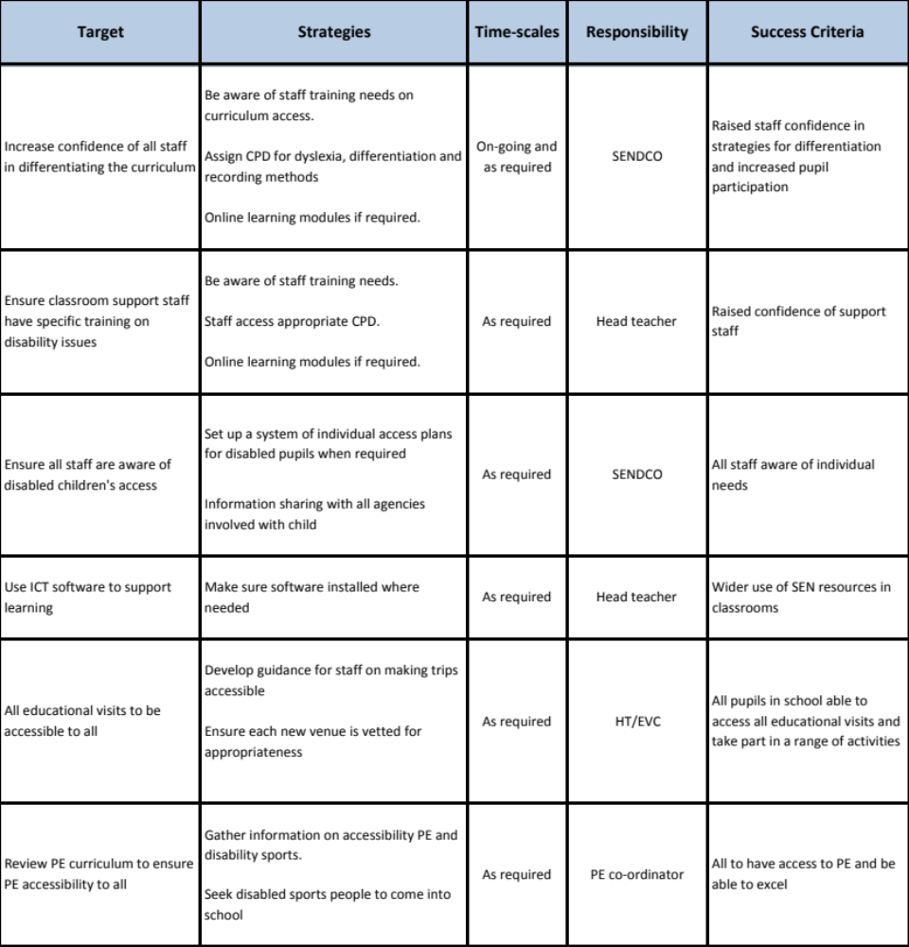It is a core value of the school that all children are enabled to participate fully in the broader life of the school. Consequently, all children are permitted to attend age relevant after school clubs, leisure and cultural activities and educational visits.
Improving access to the physical environment of the school.
St John the Evangelist School is continuing to grow and develop. It is hoped that in the future we will be able to expand the buildings and to improve the facilities across the school. All proposals to replace or upgrade accommodation will take account of the Access Plan proposals.

Provision, in exceptional cases, will be negotiated when a pupil’s specific needs are known.

We have a wide range of equipment and resources available for day-to-day use. We keep resource provision under constant review. The schools improvement planning process is the vehicle for considering such needs on an annual basis.
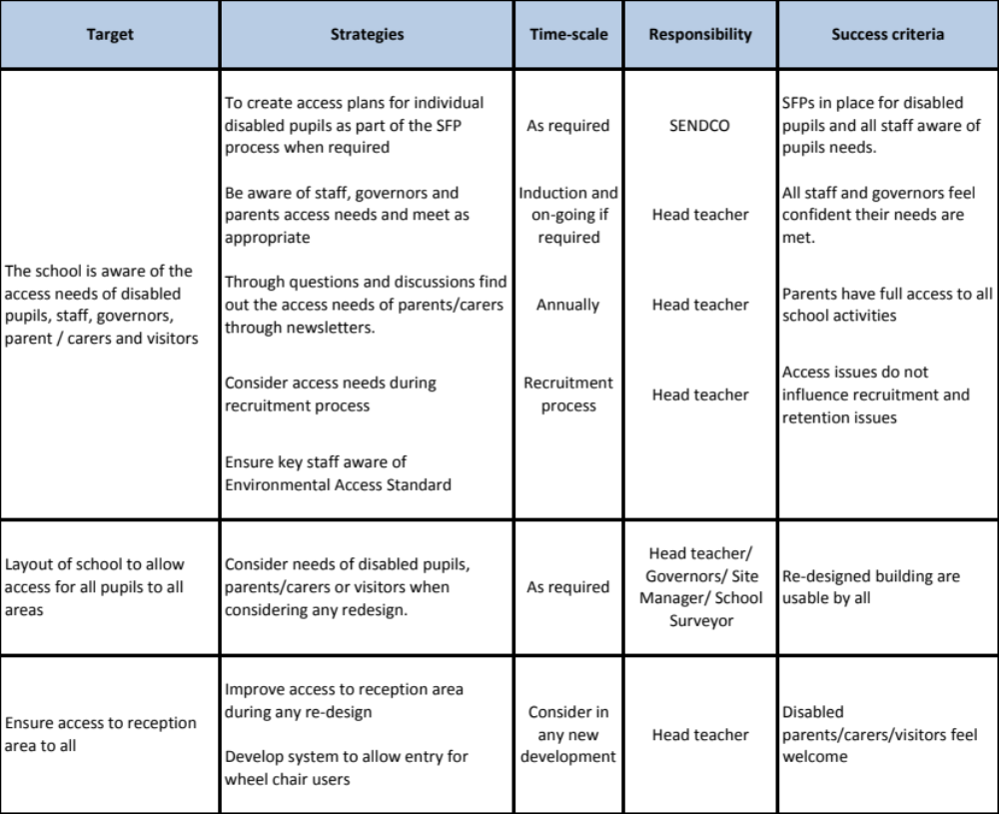

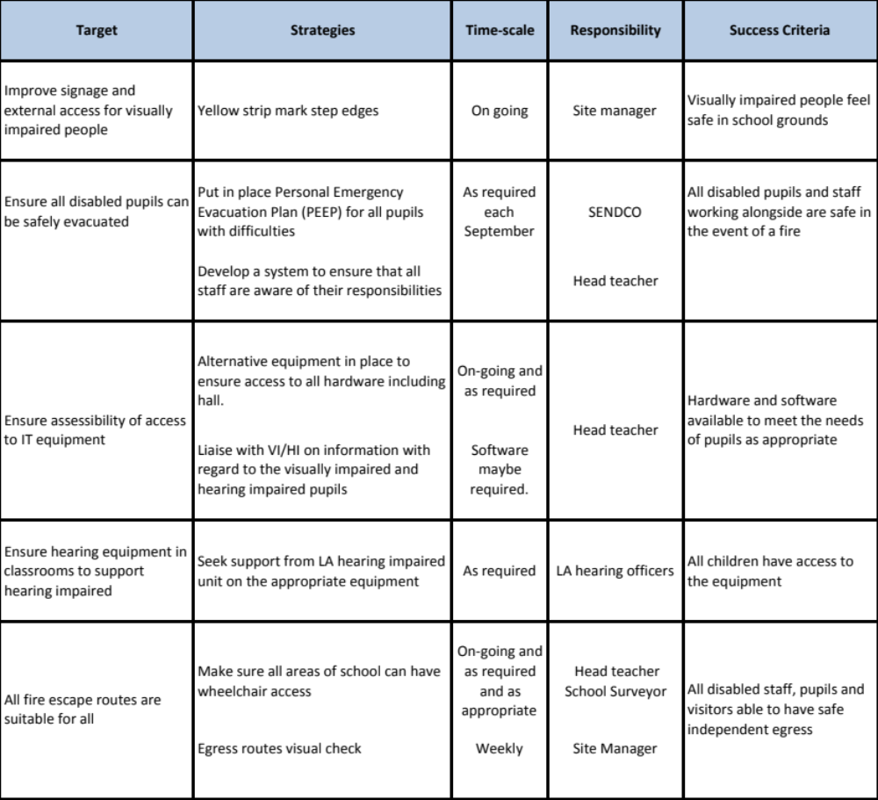

Improving the delivery of written information to disabled pupils.
This will include planning to make written information that is normally provided by the school to its pupils available to disabled pupils. Examples might include handouts, textbooks and information about school events. The information should take account of pupils’ disabilities and pupils’ and parents’ preferred formats and be made available within a reasonable timeframe.

In planning to make written information available to disabled pupils we again need to establish the current level of need and be able to respond to changes in the range of need. The school will need to identify agencies and sources of such materials to be able to make the provision when required. The schools ICT infrastructure will enable us to access a range of materials supportive to need.



