Catch-up funding action plan

Contextual information
School name | St John The Evangelist | Headteacher | Mark Harrison | Academic year | 2021 to 2022
Number of pupils | 300 | Funding allocation | £ | % PPG pupils | 10%

Background
The government announced £1 billion of funding to support children and young people to catch up lost time after school closure due to the pandemic. This is especially important for the most vulnerable and disadvantaged backgrounds. For primary schools this funding includes:
- a one-off universal £650 million catch up premium for the 2020 to 2021 academic year to ensure that schools have the support they need to help all pupils make up for lost teaching time; and
- a £350 million National Tutoring Programme to provide additional, targeted support for those children and young people who need the most help, which includes: a school’s programme for 5 to 16-year-olds – for more information, see the National Tutoring Programme FAQs, and an oral language intervention programme for reception-aged children.

The school’s funding allocation will be calculated on a per pupil basis. A mainstream primary school will get £80 for each pupil in from reception to year 6 inclusive. The school will receive funding in 3 tranches – 1. autumn 2020 – this is based on the latest available pupil data in the October census; 2. Early 2021 – based on updated pupil and place data. This payment will also take account of the initial part payment made in autumn 2020 so that the school will receive a total of £46.67 per pupil or £140 per place across the first 2 payment rounds; and 3. summer 2021 term - a further £33.33 per pupil or £100 per place.

The DfE guidance states ‘Schools should use this funding for specific activities to support their pupils to catch up for lost teaching over the previous months, in line with the curriculum expectations for the next academic year in actions for schools during the coronavirus outbreak. While schools can use their funding in a way that suits their cohort and circumstances, they are expected to use this funding for specific activities which will help pupils catch up on missed education.’
Ref: Catch up premium, published 19 November 2020
Purpose of the action plan
- To evidence how the school is using the COVID-19 funding to resume teaching the full curriculum following partial closure in the summer term 2020
- To evidence how the school is using the funding for specific activities to support pupils to catch up as a result of lost teaching in the summer term 2020 and spring term 2021.
- To enable governors and trustees to scrutinise the school’s plan for and use of catch-up funding. This includes consideration of whether the school is spending the funding in line with their catch-up priorities, and ensuring appropriate transparency for parents.

Accountability
Written by | Mark Harrison | Approved by governors
Updated | Termly | Reviewed by governors

Rationale for use of funding
Our spending has been allocated based upon the Education Endowment Foundation (EEF) evidence-based approaches for catch-up in the document coronavirus (COVID-19) support guide for schools and using the recommended implementation strategies in the EEF document school planning guide: 2020 to 2021.
Our strategic approach to the use of funding
We have adopted the 3-tier approach recommend by the EEF
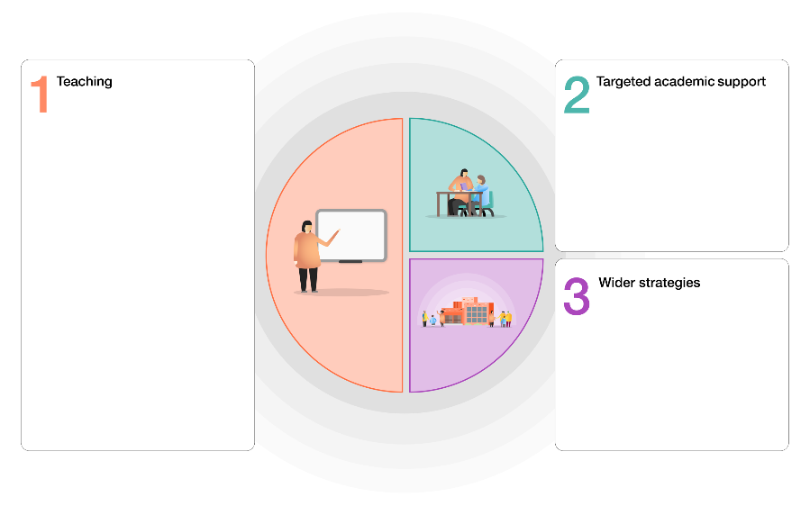
Tier 1 Teaching and whole school strategies
- Supporting great teaching
- Pupil assessment and feedback
- Transition support

Tier 2 Targeted approaches
- One to one and small group tuition
- Intervention programmes
- Extended school time

Tier 3 Wider strategies
- Supporting parent and carers
- Access to technology

Our catch up priorities |  |  |  |  | Evidence base
English – writing  - The school requires a whole school approach to writing in order to accelerate progress over time. This may require some external support.  - Many children will have struggled with support for writing from home during school closure and this is an area that we feel is more difficult to target with remote learning. |  |  |  |  | School risk assessment. Autumn term data.
English – reading  - No reading books sent home during school closure and before Christmas due to Covid.  - Reading scores in autumn in younger children below what would normally be expected. Reading is foundational to other learning and it is important that this is targeted. |  |  |  |  | School risk assessment. Autumn term data.  Staff reports
Mathematics  - In the older children the number achieving ARE was low in the autumn term.  - Fluency has been easier to continue but the reasoning needs support to achieve expected levels. |  |  |  |  | Autumn term data.  Staff reports
Wider curriculum  - Children have continued to have access to the wider curriculum during school closure. No trips/events have taken place and therefore the enrichment of the curriculum has been limited. |  |  |  |  | School timetable
Behaviour  - The behaviour of the children broadly remains good.  - The number of children who require 1:1 support for SEND support is high reducing TA hours for interventions. |  |  |  |  | CPOMS  Staff reports  timetables
Attendance  - Attendance in autumn term 2020 was comparable to previous years but attendance concerns in place for a number of children.  - Attendance during school closure is approx.. 35% with many vulnerable pupils in school.  - Monitoring of engagement in learning shows a number of children not engaging with remote learning and producing a minimal amount of work. They may require support to return to school and reengage with learning and a full school day. |  |  |  |  | Attendance reports  Engagement monitoring
Tier 1 Teaching and whole school strategies
Intent | Implementation of strategy | Est. Cost | Monitoring | Impact
Quality first teaching | Introduction of new writing approach: The Write Stuff. Whole school approach to writing which includes 7 hours of staff training, trials, resources and support.  EEF recommendation:  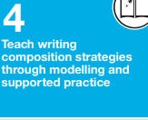  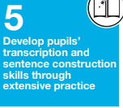 | £2000 | Comparison of writing books before and after new approach.  Assessment in writing.  Teacher and pupil reporting.
Pupil assessment and feedback | Writing support – small groups focused on need using The Write Stuff approach to model writing and develop sentence construction. 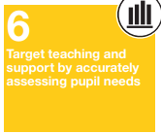 | See small group tuition. | Comparison of writing books before and after new approach.  Assessment in writing.  Scrutiny of intervention support.

Tier 2 Targeted approaches
Intent | Implementation of strategy | Cost | Monitoring | Impact
One to one and small group tuition | White Rose Hub maths tutoring (mixture of 1:2 and 1:3 support).  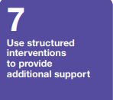 | £2715 | Assessments in school.  WRH provide report on progress. | Various levels of engagement. Children achieved well at end of Y6 considering amount of school time missed.
One to one and small group tuition | Lightning squad – paired reading tuition.  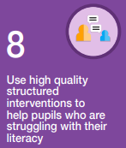 | £2200 | Assessments in school. Monitor engagement with reading.  LS provide report on progress. | Good progress shown during program and some pupils able to come off program. Use of program available afterwards.
Intervention programmes | Targeted support for children dependent on progress made during first half of academic year (additional support teacher employed). | £32 per hour X 2 days X 15 weeks = £3840 | Assessments in school.  SS to do baseline and end assessment of progress.
Targeted support from teaching assistants. | Targeted support for children dependent on progress. | Additional cost of TA for academic year: £12000
Volunteer ‘readers’ | Additional opportunities for children to read and be encouraged to develop a love of books. | Free | Assessments in school – reading comprehension.
Enrichment activities including end of Y6 adventure week. | Activities include skiing, forest school, walk, archery. | £1000 | Pupil voice | Children really enjoyed the week as evidenced by pupil voice and parental feedback and all tried activities that they hadn’t before.

Tier 3 Wider strategies
Intent | Implementation of strategy | Cost | Monitoring | Impact
Supporting parent and carers

Access to technology

Wider curriculum | Development of the use of a Forest School to inspire children, provide experiences for children after lockdown, build self-esteem and broaden curriculum offer. | Cost to come from sports grant | Case study of small number of children monitoring engagement, attendance, attitude towards school and assessment scores.
Behaviour

Attendance

Summary
 | Cost | Impact summary statements
Tier 1 Teaching and whole school strategies
Tier 2 Targeted approaches
Tier 3 Wider strategies
 | Total expenditure

