St John the Evangelist Ce Aided Primary School
Uniform Policy September 2023

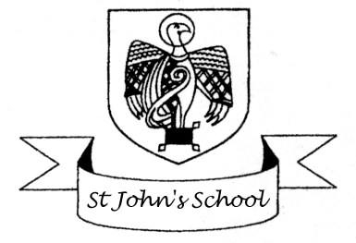
As a school we believe that the wearing of school uniform is a key part in creating and maintaining our school identity. It helps children to feel that they belong, and engenders a sense of pride. It prevents differences between children on economic grounds and prevents a ‘fashion contest’, as everyone looks the same.
The uniform as set out in this policy is compulsory for all pupils. Staff will strictly apply the rules on dress. If a child arrives incorrectly dressed parents will be contacted and asked to bring the correct uniform into school. If there is a good reason why your child has temporarily come to school without the correct uniform parents should write a letter clearly explaining the reasons.
We are confident that parents will continue to support us in our ‘smart look’ and ensure their children are correctly dressed for school.
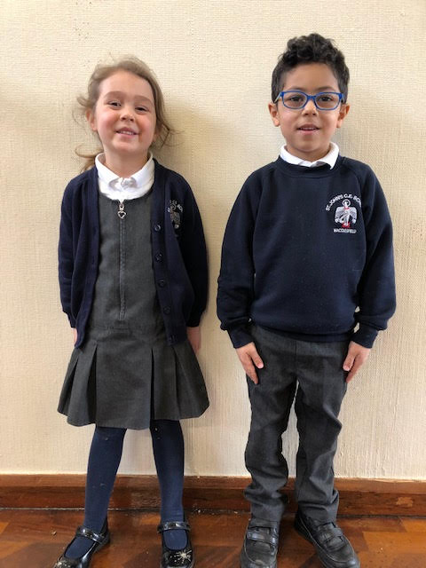
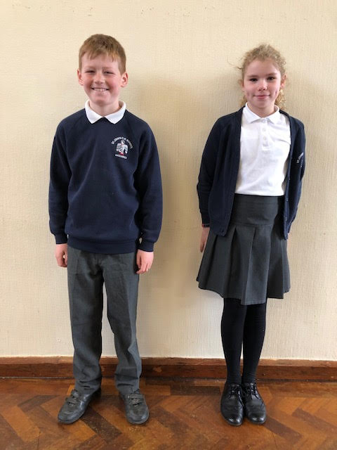

Compulsory for all pupils
Girls | Boys
Sweatshirt/Cardigan  Navy school sweatshirt or cardigan with school logo. Plain sweatshirts are not acceptable. | Sweatshirt  Navy school sweatshirt with school logo. Plain sweatshirts are not acceptable.
Shirts  White collared-3 button, short sleeved Polo shirt (either plain or with logo). | Shirts  White collared -3 button, short sleeved Polo shirt (either plain or with logo).
Skirts  Grey skirt/pinafore/ tunic or culottes.  These should be approximately knee length. If a skirt is deemed to be too short parents will be asked to replace it | Trousers.  Grey Short or long. Plain and tailored with a waistband  Uniform can be purchased from Finesse on Mill Street or Trutex on King Edward Place
Trousers.
Grey Plain and tailored with a waistband. Stretch pants and leggings are not permitted.
Summer Dresses should be mid blue and white -gingham or stripes.
Socks-white or grey ankle or knee length.  Tights opaque navy or grey | Socks should be plain grey ankle or knee socks -not trainer socks.
Shoes -Black sturdy and low heeled. Fabric shoes, pumps or boots are not acceptable. | Shoes -Black and sturdy Fabric shoes pumps or boots are not acceptable.
Coat  Outdoor waterproof coat with a hood (hoodies are not permitted). | Coat  Outdoor waterproof coat with a hood (hoodies are not permitted).
Jewellery
No jewellery or accessories. A wrist watch may be worn but must be removed for PE.
Children may wear a small plain ear stud. You can buy clear ones made for wearing in school.
Hair
Extremes of hairstyle are not acceptable. Gel and other hair products should not be worn. Patterns should not be shaved into hair. Shoulder length hair or longer must be tied back at all times. A plain bobble should be used. If a headband is worn it should be in school colours –blue or white.
School bag-this should be either a small back pack or a school book bag. Large bags cannot be accommodated in the cloakroom areas.
PE Uniform
St Johns pump bag PE shorts – plain black/blue Trainers (or pumps)
PE top –Logo PE top or plain blue tee shirt.
In winter plain black or navy joggers may be worn outside.
PE kit will be worn on PE days and children should come to school dressed in appropriate PE kit. For Forest School children should have wellies in school which can be stored in the welly shed. Waterproof trousers and coat would also be useful in the winter.

